

Project Report

CSE 405

Computer Networks

**Submitted to-**

Dr. Anisur Rahman

Associate Prof, Department of Computer Science and Engineering,

East West University.

**Submitted By-**

Zarin Tasnim Nuzhat

ID: 2020-1-60-211

**Section-**3

**Semester-** Fall 2022

**Submission Date-** 15/01/2023

**Title:** Design a full-fledged network for an organization with multiple subnets.

**Introduction:**

University of Scholars, is an enterprise like East West University, owns many computers, with a complex network infrastructure. Apart from wired internet access to all the classrooms, labs, employee PCs, library and other administrative and academic wings, the university also provides wireless internet access for every campus. On top of that, the university runs complex networked systems to support several of its business process like admissions, advising, results, eTender, library management, accounts and so on.

**Tools:**

* Cisco Packet Tracer Software (version 8.2.0)
* Laptop-Pt, Pc-Pt , Printer, Smartphone, Tablet.
* Switches (2960)
* Routers (PT)
* Access Point-PT (Wireless Device)
* Server-PT (Single Server For WEB, DHCP and DNS)
* Connectors (Copper straight through, Serial DCE)

**Tasks Completed:**

* Web page of the university reflects University of Scholars’ web page because of all devices is connected to the server, which is acting as WEB, DHCP & DNS server.
* DNS sever was installed to locate webserver which redirects us to the website of University of

Scholars.

* Single DHCP server provides all of the required IP to all of the networks.
* Wireless links to the networks are available.
* University’s full network has covered its seven campuses with seven routers;
* Connectivity between all the hosts has been established.

**Network Diagram:**

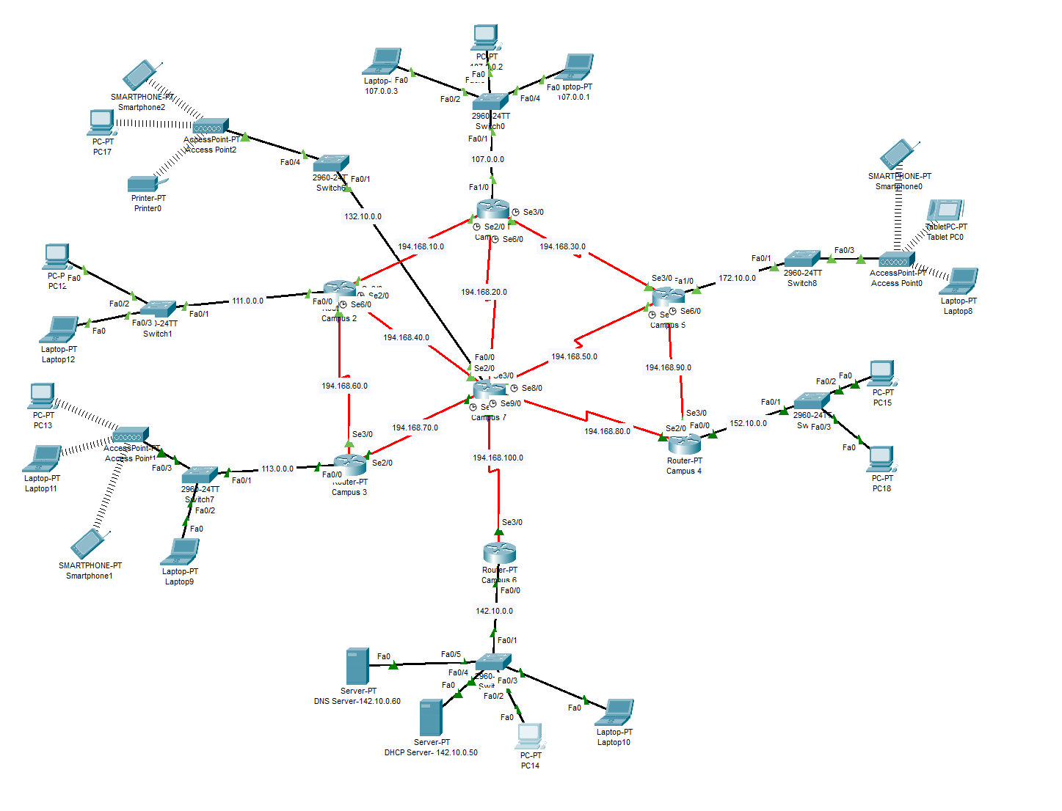

**Setup and configuration:**

I have used Class A network for the hosts (107.0.0.0, 111.0.0.0, 113.0.0.0) and also used Class B (132.10.0.0, 142.10.0.0, 152.10.0.0, 172.10.0.0) , Class C networks for Router’s Connector networks (194.168.10.0, 194.168.20.0, 194.168.30.0, 194.168.40.0, 194.168.50.0, 194.168.60.0, 194.168.70.0, 194.168.80.0, 194.168.90.0, 194.168.100.0), and for Server network I have used class B network 142.10.0.50 and 142.10.0.60.

**For The Router IP Setup We have used a CLI code for each router,**

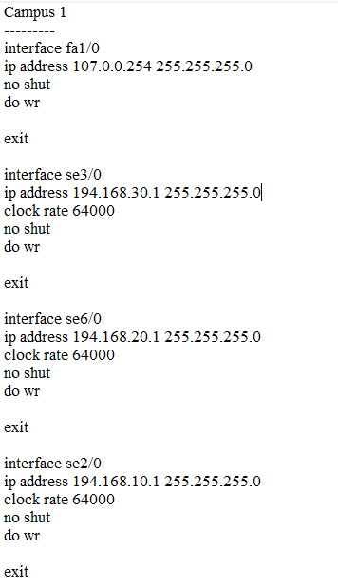 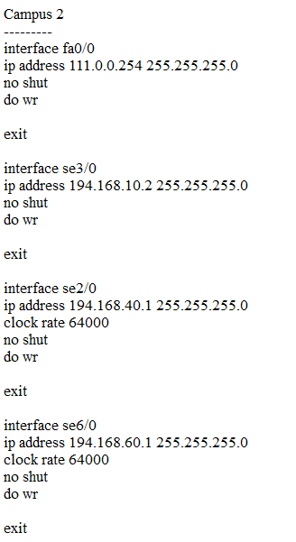

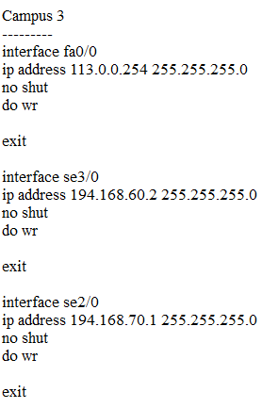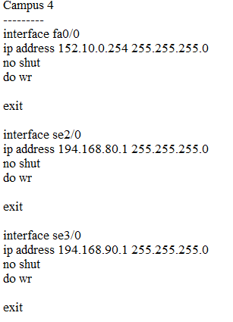

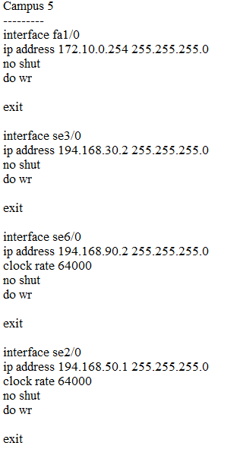 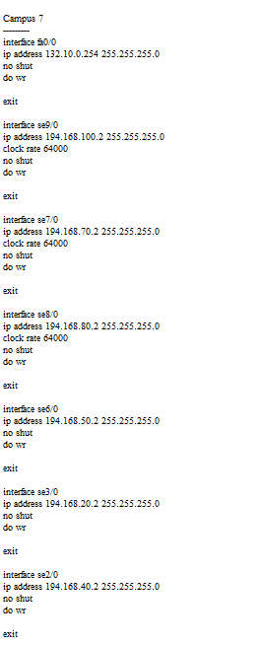

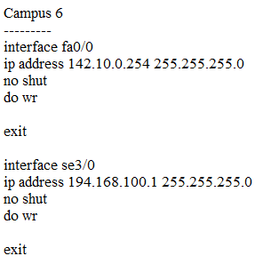

**To setup the Routing Table I have used the following CLI Code,**

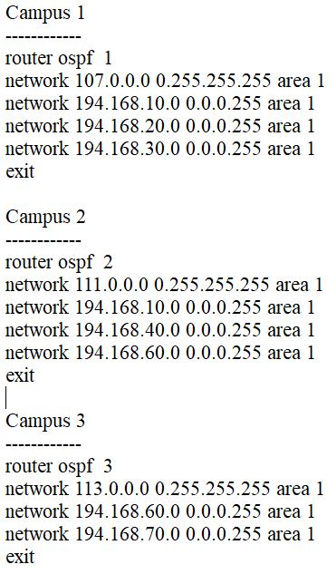 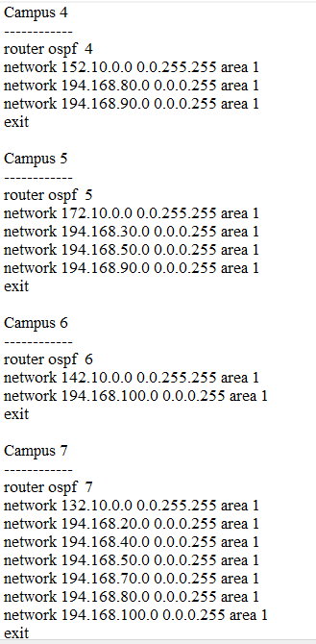

To establish connection between the servers with all the other networks, I have used IP helper address, as it is a remote DHCP for other networks.

I have set the IP of the server to 142.10.0.50and set the helper address to all the interfaces as cli code, IP helper-address 142.10.0.50.

**Server Setup:** 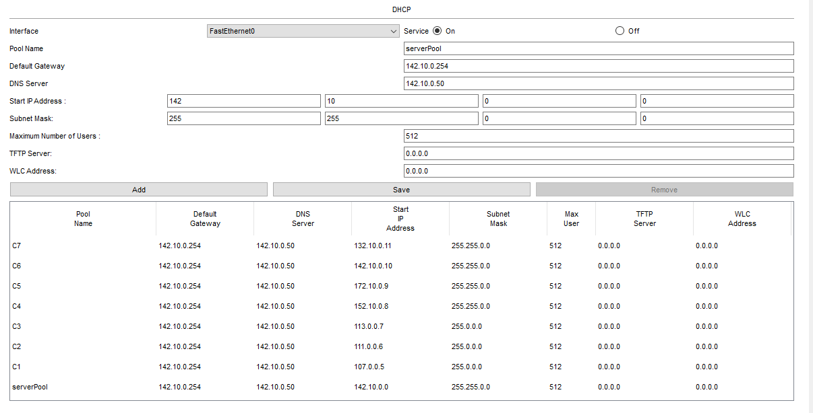

Here, I have made some pools that would generate the IP range for different networks In the DHCP

Server.

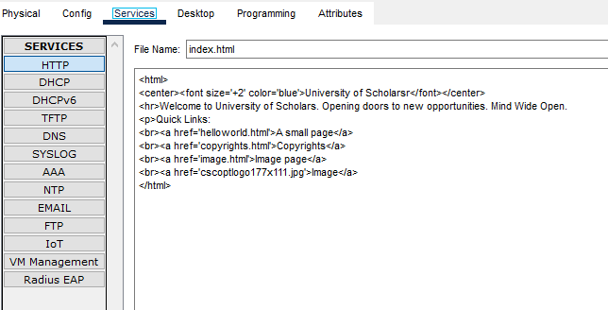

This will work as out http server and run the page index.html.

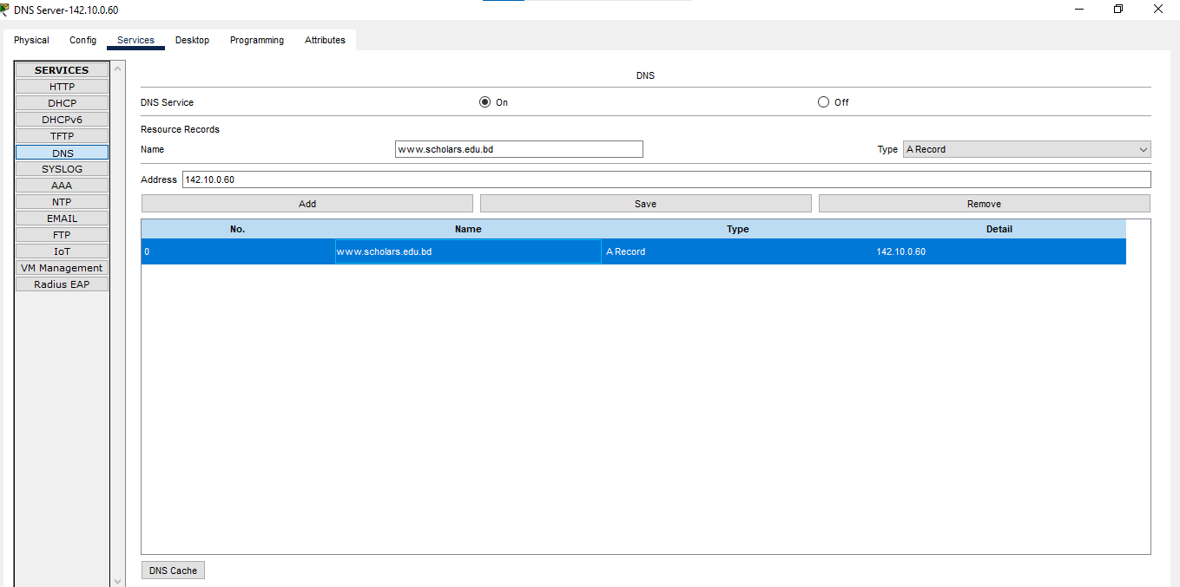

This is the DNS server.

**Running the webpage from a PC:**

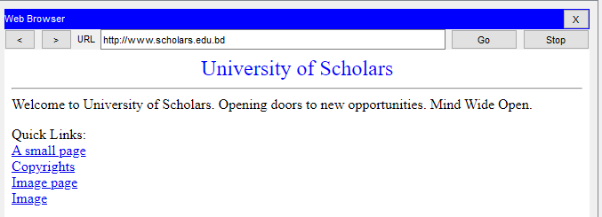

**Conclusion:**

Here I used OSPF network architecture to configure the routers easily. I used wired and wireless connection also. I used DNS web server, DHCP server for setup IP address for every hosts. After all, every host could connect with each other.